**OZWIN ISSUE**

We are experiencing a major drop in FTDs at Ozwin, most notably since October 2021. With a drastic drop in Nov 2021, and based on the last weeks stats, a further 16% drop expected in Dec 2021 (compared to Nov 2021). 16% is expected if more affiliates don’t remove us. If they do, this of course will be more.

**FTDs by month since launch**

May 2020 - 1212

Jun 2020 - 2213

Jul 2020 - 3795

Aug 2020 - 3864

Sep 2020 - 5837

Oct 2020 - 4752

Nov 2020 - 3883

Dec 2020 - 3897

Jan 2021 - 3556

Feb 2021 - 3067

Mar 2021 - 2625

Apr 2021 - 2085

May 2021 - 1855

Jun 2021 - 1870

Jul 2021 - 2259

Aug 2021 - 2073

Sep 2021 - 1841

**Oct 2021 - 1417 - Down 23% on previous month**

**Nov 2021 - 822 - Down 42% on previous month**

**Dec 2021 - 691 (Projected based on last 7 days) - Down 16% on previous month**

Refer to Attached reports **'OW top 7 affs Jul vs Nov'** and **'OW top 2 affiliates month on month'** for breakdown of various data.

There is a clear drop in 'Click to FTD' and also 'Click to Sign up' for all of our top affiliates. Due to this, we have lost top positions and traffic is now lower.

------------

**OW Internal PPC ads**

Our own OW PPC ads in Google

**Month by month Average CPA**

Jan 21 - €174.40

Feb 21 - €191.22

Mar 21 - €182.28

Apr 21 - €254.70 - OW URL blocked for first time, jump in CPA

May 21 - €258.58

Jun 21 - €272.21

Jul 21 - €247.16

Aug 21 - €282.22

Sep 21 - €272.46

**Oct 21 - €387.97 - Another big jump in CPA in October 21**

**Nov 21 - €390.31**

**Last 10 days....**

€286.15

€1,134.32

€419.00

€607.66

€1,328.59

€722.02

€979.18

0 FTDs - First time ever

€232.33

€519.31

As you can see there is no consistency at all in these stats, suggesting an issue with the casino. Bids and clicks are from the same Keywords every day.

----

**Notable Action taken so far:**

Ticket opened with RTG for a general check to see if they can see any issues.

**CS-44923**

Hi

We have a steep decline in FTDs on Ozwin the last months and it continues to drop, -62% since end July... This obviously is not normal.

There seems to be an issue with 'click to sign up'. Affiliates click to sign up rate has increased drastically. For example one of our top ads used to convert 1 sign up in 10 clicks, now 1 in 17 clicks.

Sign up to FTD seems to be fine. So once they do sign up, they convert the same as they used to.

Please can you check for any issues on your side at sign up level on this brand and look for anything that may be causing this?

Sometimes when I try to create an account the 'NEXT' button and 'Register' button takes a very long time to light up once all fields are complete, perhaps players are experiencing similar issues?

Please can you check this and any other issues that you think may be stopping players from completing the sign up form. Your help with this is greatly appreciated.

Thanks

---

Feedback from Alla on this ticket

“Sometimes when I try to create an account the 'NEXT' button and 'Register' button takes a very long time to light up once all fields are complete, perhaps players are experiencing similar issues?”

- This delay is due to the special sign up check Vladan and BI team implemented back in September – they on purpose delay the appearance of the button while they check whether a customer has older accounts with us. If they do, they push a dedicated message, inviting to rather log in to an older (depositing) account. Here is some more info on that: https://ags-jira01.intertops.co.ag/browse/DEV-7414

---

RTG feedback

**Thank you for contacting us, we are glad to assist you on this incident. After reviewing the issue, we were not able to face the delay on the Register or Next button, however, on the DevTools we noted this "Slow server response":**

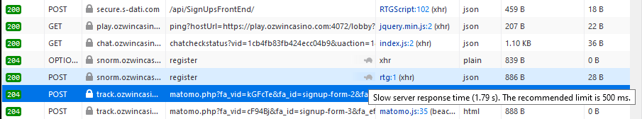

**Which seems to be related with a custom script, so, could you please double check the custom script placed on the Admin > Configuration > Lobby> Custom Script to verify if there are any implementation that could cause this delay?**

**Please keep us posted and if you have any questions, please feel free to contact us.**

---

Awaiting a response our side on this.

---

**Alla’s Comments and Feedback**

* Australian domain is not blocked / is working properly when accessing it via Chrome VPN
  + A real test from Australia would be beneficial, especially considering the fact that Aussies use all kind of VPN apps to avoid disclosure of their location.
* Sign up forms (mobile and desktop) work properly - daily tested by Manju, occasionally tested by Alla.
* Welcome emails and promotional emails work fine, very good opening rates.
* 100% cashback on the 1st deposit was launched to boost conversion (30.11).
* **New Customer Report in DF** shows the ‘email blacklisted’ error, which comes from a processor. Quick investigation showed several customers being prevented from depositing because of this error. Deeper investigation is required to get a feeling for the scope of this problem.   
  Original email is below:

“You know we are experiencing massive issues with First Time Depositors ratio, as well as overall deposits at Ozwin, and we are trying to look for any possible hint as to why this is happening.

I was looking into newbies at Ozwin who had deposit attempts but never succeeded to deposit (I checked the last 7 days). The following error appears quite often (but I am not sure if this is a normal behaviour):

*status:declined##technical_message:Transaction declined by risk management, 'email' is blacklisted!##*

When checking WIKI, I see that support agents are not able to help those players and Risk team is analysing such cases: (ss01)

As an example, please check the following customer:

**Ozwin_BecBextacy**

She has joined Ozwin on the 26th of November and immediately attempted to deposit. She tried 4 times, according to the screenshot below. We have not reached out to her explaining what happened and what can help. I see she even proactively sent us a_form, ID documents which shows she was really willing to become a depositing player at Ozwin: (ss02)

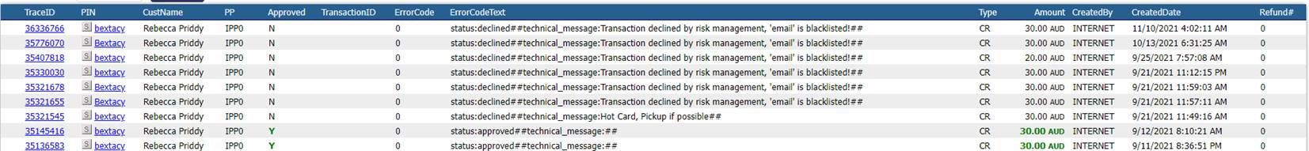I can see that she has a depositing account ($5,200) at Fair Go (**Bextacy)** – she is with us since 2017 and the trust is there.After checking her Fair Go account, I see she had to stop depositing with us in September because of the exact same reason (email is blacklisted).   
Customer tried depositing again and again, she tried asking for help, but it was all unsuccessful – we were only advising to use alternative methods: (ss03)

There are a few more players who I came across, experiencing the same issue: jrmf1992 (has many depositing accounts across our group), mikaproc94 (no accounts across our group).

**Could you please clarify the following for us:**

* Why would such an error appear and how “serious” is it?
* Could you see if the ratio for such errors increased in the last 2 months?
* Are you checking players that experience this issue on the regular basis and are you reaching out to them proactively?
* What are the steps for the customers – are we inviting to update their email addresses or only advising to use alternative methods?

If I understand it correctly and we can update their email address – the issue will be resolved and the customer will be able to make deposits at Fair Go and Ozwin? “

* Player Conversion Report form RTG BO, showing that less and less customers are making their first deposit:

